Prepositions of Cause, Reason, or Purpose

🔹 What Are Prepositions of Cause, Reason, or Purpose?
# Source: AI Source: Provided by: [Data Path: Persons Table -> ID Column: 1, Name_En Column: Motasem Essam] -> From: [Chatgpt (GPT-4-turbo)] on [7/28/2025]
Prepositions of cause, reason, or purpose show why something happens — the cause, reason, or purpose behind an action or event.
They answer the questions: Why? Because of what? For what purpose?

✅ Common Prepositions of Cause, Reason, Purpose
# Source: AI Source: Provided by: [Data Path: Persons Table -> ID Column: 1, Name_En Column: Motasem Essam] -> From: [Chatgpt (GPT-4-turbo)] on [7/28/2025]
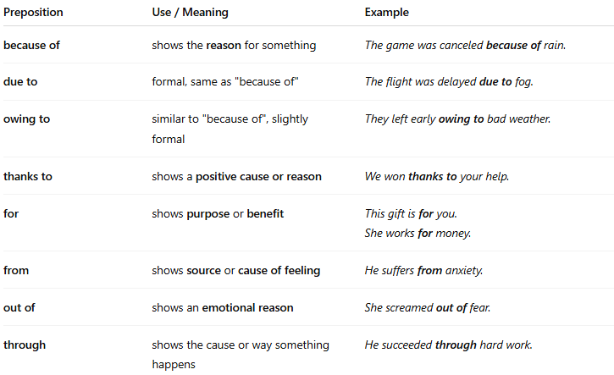
Preposition | Use / Meaning | Example
because of | shows the reason for something | The game was canceled because of rain.
due to | formal, same as "because of" | The flight was delayed due to fog.
owing to | similar to "because of", slightly formal | They left early owing to bad weather.
thanks to | shows a positive cause or reason | We won thanks to your help.
for | shows purpose or benefit | This gift is for you.She works for money.
from | shows source or cause of feeling | He suffers from anxiety.
out of | shows an emotional reason | She screamed out of fear.
through | shows the cause or way something happens | He succeeded through hard work.

📚 Example Sentences
# Source: AI Source: Provided by: [Data Path: Persons Table -> ID Column: 1, Name_En Column: Motasem Essam] -> From: [Chatgpt (GPT-4-turbo)] on [7/28/2025]
- The road was closed because of an accident.
- They stayed home due to heavy snow.
- He cried out of joy.
- Thanks to her support, we finished early.
- She acted from kindness.

